**Project 2: Development of Applications using Orchestration, Containerization, and IAC Tools**

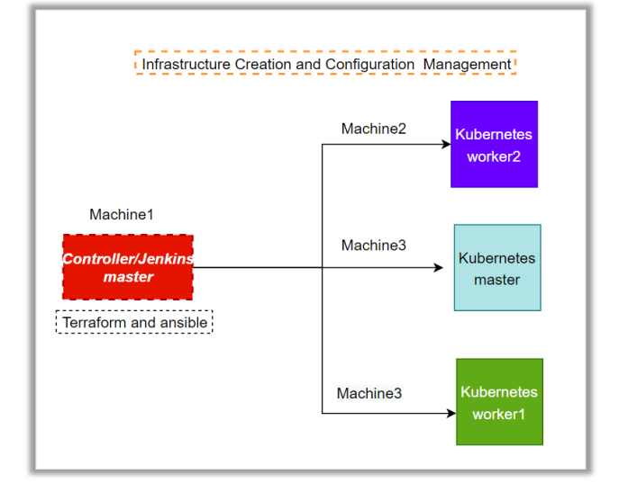

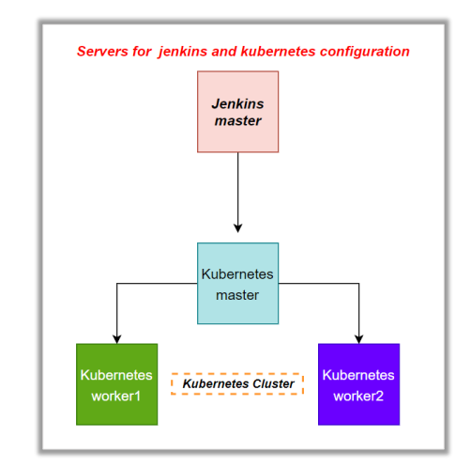

Project 2: Development of Applications using Orchestration, Containerization, and IAC tools.

* Automated containerized application deployment using GIT, Docker, Jenkins, Kubernetes, and Terraform
* Creating Kubernetes cluster in AWS using IAC (Terraform)
* Implemented CI/CD Pipeline with Jenkins using Jenkin script
* Creating Kubernetes cluster for orchestration of container and creating node port service
* All the above work has been done by Jenkin pipeline script

Tools used for the project

Jenkin – creating CI/CD pipeline

Git – creating git workflow

Terraform -creating intances for Kubernetes cluster

Docker -containerize the code

Kubernetes – for container orchestration

Containerizing application with Docker file, and implemented GIT workflow